Subject & Subject Code: Engineering Mathematics-2, 2FY1-01
Semester: II Branch: All
Note: Data may be changed.

References:
- Engineering Mathematics – D.C. Gokhroo & V.C. Jain, Unique Publication
- Advanced Engineering Mathematics – Erwin Kreyszig, John Wiley & Sons
- Advanced Engineering Mathematics – R.K. Jain & S.R.K. Iyengar, Narosa Publication
- Higher Engineering Mathematics – B.V. Ramanna, McGraw Hill Education
- Engineering Mathematics – Srimanta Pal & Subodh C. Bhunia, Oxford University Press
- Engineering Mathematics – A.R. Vashistha & Vipin Vashistha, Pragati Prakashan
- Calculus – Vashistha, Vashistha & Vashistha, Krishna Prakashan
- Advanced Engineering Mathematics – H.K. Das, S. Chand
- Higher Engineering Mathematics – B.S. Grewal, Khanna Publishers
- Higher Engineering Mathematics – Y.N. Gaur & C.L. Koul, Jaipur Publishing House

Part A (40 Questions)
Q1. Define of rank of a matrix. Where it is used?
Solution. A matrix A is said to be of rank r, if at least one of its minors (sub- determinants) of order r is non-zero and all minors of order greater than r are zero. It is written as rank (A) = r or ρ(A) = r.
The rank of matrices is used in the solution of simultaneous linear equations.
Q2. What is Echelon form of a matrix?
Solution. A matrix A is said to be in echelon form, if
- a row of A, which has all its elements zero occurs below a row, which has non-zero element(s) and
- the number of zeros before the first non-zero element in a row is less than the number of such zeros in the next row.
The rank of matrix in echelon form is equal to the number of non-zero rows in the matrix.
Q3. Explain normal forms of a matrix.
Solution. If A be a matrix of rank r (> 0) and order m×n, then by applying elementary transformations (row operations and column operations), A can be reduced into one of the following forms:
[I_{r}] (m = n = r),
[I_{r} O] (m = r, n > r),
[Ir] (m > r, n = r),
O
[Ir O] (m > r, n > r).
O O
These forms are called normal forms or canonical forms of the matrix A. A zero matrix has its own normal form.
Q4. Explain Nullity of a Matrix.
Solution. The nullity of a matrix A is the dimension of the null space of A and is denoted by N(A).

The nullity of the identity matrix I is 0 and the nullity of the null matrix O of order m×n is n.
Q5. State rank-nullity theorem.
Solution. The sum of the rank and the nullity of a matrix equals to the number of the columns of the matrix.
If A be a matrix of order m×n, then ρ(A) + N(A) = n.
This theorem is also known as the dimension theorem.
Q6. Explain consistency and inconsistency of a system of linear equations.
Solution. A system of linear equations is said to be consistent, if it has at least one set of solution. On the other hand, a system is said to be inconsistent, if it has no solution.
Q7. Define eigen-values of a matrix.
Solution. If A be a square matrix of order n, I be the identity matrix of order n and λ be a scalar, then A ‒ λI is called characteristic matrix of the matrix A; ǀA ‒ λIǀ is a polynomial function of degree n in λ and is called characteristic function or characteristic polynomial or eigen function of the matrix A; ǀA ‒ λIǀ = 0 is called characteristic equation of the matrix A; roots of ǀA ‒ λIǀ = 0 are called characteristic roots or latent roots or eigen values of the matrix A.
Q8. Explain eigen-vectors of a matrix.
Solution. a non-zero vector X exists such that AX = λX, then X is called characteristic vector or latent vector or eigen vector of the matrix A corresponding to the eigen value λ of the matrix A.
AX = λX ⇒ AX ‒ λX = O ⇒ AX ‒ λIX = O ⇒ (A ‒ λI)X = O, which is a homogeneous system of linear equations and has infinite many non-trivial solutions to give parallel vectors, since ǀA ‒ λIǀ = 0.
Q9. What is diagonalisation of square matrix?
Solution. A square matrix A of order n has n linearly independent eigen vectors X₁, X₂, ···, X_{n} corresponding to the eigen values λ₁, λ₂, ···, λ_{n} , then the matrix A can be reduced to a diagonal form such that P^{‒1}AP = D,

where P = [X₁ X₂ ··· X_{n}] and D = diag. (λ₁, λ₂, ···, λ_{n}).
Q10. State and explain Cayley Hamilton theorem.
Solution. Every square matrix satisfies its own characteristic equation.
If A be a square matrix of order n, then its characteristic equation is ǀA ‒ λIǀ = 0 ⇒
(‒1)^{n}λ^{n} + a₁λ^{n‒1} + a₂λ^{n‒2} + + a_{n‒1}λ + a_{n} = 0.
By Cayley-Hamilton theorem, matrix A satisfies above equation so that (‒1)^{n}A^{n} + a₁A^{n‒1} + a₂A^{n‒2} + + a_{n‒1}A + a_{n}I = O.
Q11. What is scalar field?
Solution. We know that a scalar quantity possesses only magnitude and has no concern with direction. A single real number gives us a complete representation of a scalar quantity. Thus a scalar quantity is nothing but a real number.
If to each point P(x, y, z) of a region R in space there corresponds a unique scalar f(P), then f is called a scalar point function and we say that a scalar field f has been defined in R.
Q12. Define vector field.
Solution.If to each point P(x, y, z) of a region R in space there corresponds a unique vector f(p), then f is called a vector point function and we say that a vector field f has been defined in R.
Q13. What is the vector differential operator?
Solution.The vector differential operator ∇ (read as del or nabla) is defined as

∇ ≡ ∂ iˆ + ∂
∂x ∂y
ˆj + ∂
∂z
kˆ ≡ iˆ ∂
∂x
+ ˆj ∂
∂y
+ kˆ ∂
∂z

and operates distributely.

The vector operator ∇ can generally be treated to behave as an ordinary vector. It
∂ , ∂ , ∂

possesses properties like ordinary vectors. The symbols ∂x ∂y
its components along iˆ, ˆj, kˆ .
Q14. Define gradient of a scalar field.
∂z can be treated as

Solution.Let f(x, y, z) be defined and differentiable at each point (x, y, z) in a certain region of space 9i.e., defines a differential scalar field). Then the gradient

of f, written as ∇f
or grad f, is defined as

∇f=⎛ ∂ iˆ + ∂
ˆj + ∂
ˆ⎞ ⎛ ∂f iˆ + ∂f
ˆj + ∂f kˆ⎞

⎜ ∂x ∂y ∂z k ⎟f=⎜ ∂x ∂y ∂z ⎟

⎝ ⎠ ⎝ ⎠

∂f , ∂f , ∂f

It should be noted that ∇f
is a vector, whose three components are ∂x ∂y
∂z .

Thus the gradient of a scalar field defines a vector field. If f is a scalar point

function, then∇f
is a vector point function.

Q15. Explain divergence of a vector point function.
Solution.Let V be any differentiable vector point function. Then the divergence of V, written as ∇.V or div V, is defined as

div V=∇.V = ⎛ iˆ ∂
+ ˆj ∂
+ kˆ ∂ ⎞ ⎛ ˆ ∂V + ˆj. ∂V + kˆ. ∂V ⎞ = ∑iˆ. ∂V

⎜ ∂x ∂y ∂z ⎟.V= ⎜ i . ∂x ∂y ∂z ⎟ ∂x
⎝ ⎠ ⎝ ⎠ .
It should be noted that div V is a scalar quantity. Thus the diveregence of a vector point function is a scalar point function.
Q16. What is curl of a vector point function?
Solution.If f be a given differentiable vector point function. Then the curl or rotation of f , written as ∇× f , curl f or rot f is defined as

curl f
= ⎛ iˆ ∂
+ ˆj ∂
+ kˆ ∂ ⎞×
⎛ ˆ× ∂f
+ ˆj × ∂f
+ kˆ× ∂f ⎞ = ∑iˆ× ∂f

⎜ ∂x ∂y ∂z ⎟ f =⎜ i ∂x ∂y ∂z ⎟ ∂x
⎝ ⎠ ⎝ ⎠ .
It should be noted that curl f is a vector quantity. Thus the curl of a vector point function is vector point function.
Q17. Define vector line integral.

Solution.fC
¯F→ · dr→ = fC
(F₁dx + F₂dy + F₃dz)

is called the line integral of the vector point function ¯F→ along the curve C.

If ¯F→ be the force acting on a particle moving on the curve C, then the line integral
fC ¯F→ · dr→ gives the work done by the force ¯F→ in displacing the particle along the
curve C.
Q18. State Green’s theorem.
Solution.. If M(x, y) and N(x, y) are continuously differentiable functions in a region S in xy-plane bounded by a simple closed curve C, then
f (Mdx + Ndy) = ∬ (6N − 6M) dxdy,

C S 6x 6y
where C is taken in positive sense (anticlockwise direction).
Q19. State Gauss’s divergence theorem.
Solution.If F→ is a continuously differentiable vector point function in a region V enclosed by a closed surface S, then

fS ¯F→ · k^ dS = fV
A · ¯F→ dV,

where k^ is the outward drawn unit normal vector to the surface S.
Q20. State Stoke’s theorem.
Solution.If F→ is a continuously differentiable vector point function in a region V enclosed by a closed surface S, then

fS ¯F→ · k^ dS = fV
A · ¯F→ dV,

where k^ is the outward drawn unit normal vector to the surface S.
Q21. What is general equation of sphere? Solution: The general equation of a sphere is x²+ y²+z² +2ux+2vy+2wz+d=0
Its centre is (-u, -v, -w) and radius is r = √(u2 + v2 + w2 − d) .
Q22. Write diameter form the equation of sphere.
Solution: The equation of the sphere with (x₁, y₁, z₁) and (x₂, y₂, z₂) as extremities of a diameter is (x- x₁)( x- x₂)+( y-y₁)( y-y₂)+(z-z₁)( z-z₂) = 0.

Q23. What is great circle?
Solution: The intersection of a sphere and plane is a circle. If the plane intersect the sphere through centre of the sphere, then the generated circle is a great circle. The radius of the great circle is equal to the radius of sphere.
Q24. What is the condition of tangency of a plane and sphere?
Solution: The plane
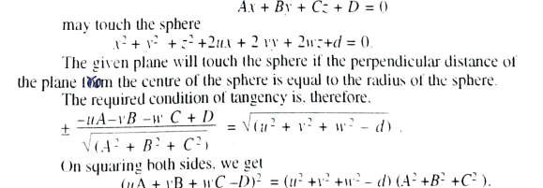
Q25. Explain the condition of two spheres touch externally and internally.
Solution: The conditions are as:
Q26. Define orthogonal spheres and also write condition of orthogonality.
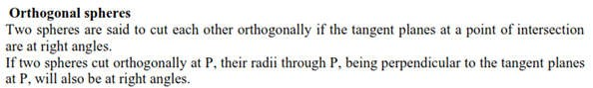
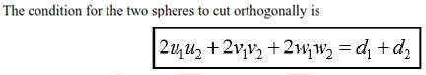
Solution:
Q27. Define right circular cone.

Solution: A right circular cone is a surface generated by a line which passes through a fixed point and makes a constant angle with a fixed line through the fixed point.
The fixed point is called the vertex; the fixed line is called the axis and the constant angle is called the semi-vertical angle of the right circular cone.
Q28. Define right circular cylinder.
Solution: A right circular cylinder is a surface generated by a line which intersects a fixed circle and is perpendicular to the plane of the circle.
The circle is called the guiding circle; its radius is called the radius of the cylinder and the normal to the plane of the guiding circle through its centre is called the axis of the cylinder.
Q29. Define surface of revolution.
Solution: When a curve is rotated around a fixed straight line lying on the plane of the curve, a surface is generated, which is called the surface of revolution. The fixed line is called the axis of revolution or rotation. The rotating curve is called the generator of the surface.
Q30. Write the formula of surface of revolution about x axis, when the equations of the curve are in parametric form.
Solution:
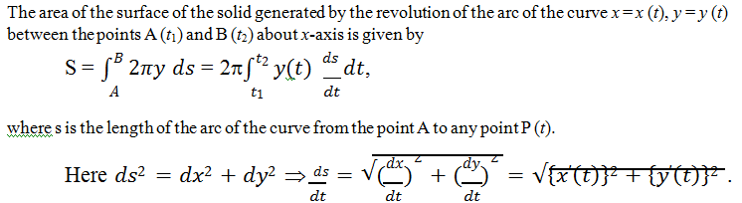
Q31. What is the volume of solid of revolution?
Solution: When a plane area revolves about a fixed line, it generates a solid, which is called the solid of revolution. The fixed line is called the axis of revolution or rotation.

Q32. Write the formula of volume of solid of revolution about y axis, when the equation of the curve is in cartesian form.
Solution:
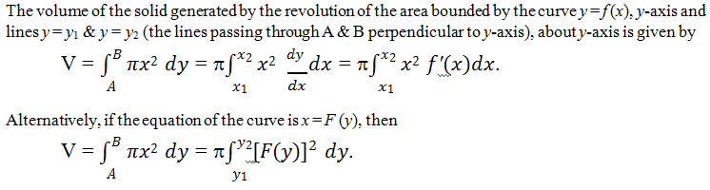
Q33. Define Gamma Function.
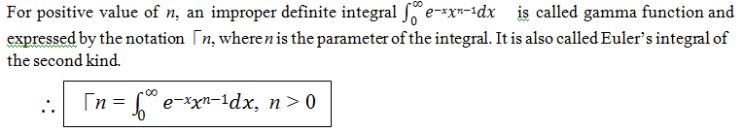
Solution:
Q34. What is trigonometric form of the beta function?
Solution: The trigonometric form of the beta function is given by
.
Q35. Write the gamma formula.
Solution: The gamma formula is defined as:
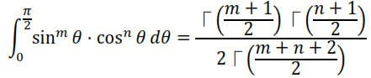
Q36. Write the Legendre's duplication formula.
Solution: The Legendre's duplication formula is as:
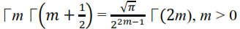

Q37. Evaluate:
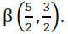
Solution:
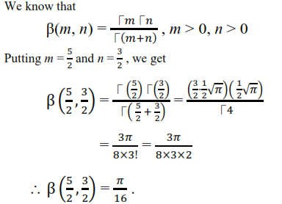
Q38. Evaluate:
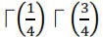
Solution:
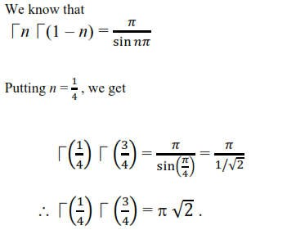

Q39. Define double integral.
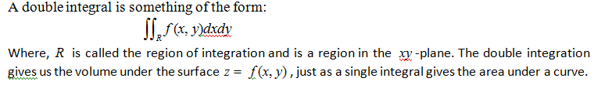
Solution:
Q40. Explain the change of order of integration in double integral.
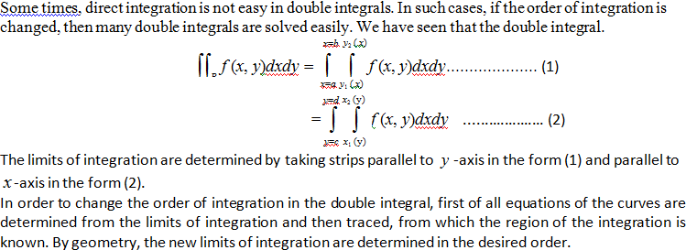
Solution:

Part B (15 Questions)
0 1 ‒ 3 ‒ 1
Q1. Reduce the matrix A = [1 0 1 1 ]
3 1 0 2
1 1 ‒ 2 0
in its normal form and hence find its rank.

0 1 ‒ 3
Solution. Given A = [1 0 1
3 1 0
– 1
1 ].
2

1 1 ‒ 2 0
Applying R₁ ↔ R₂, we get

1 0 1
A ~ [0 1 ‒ 3
3 1 0
1
– 1].
2

1 1 ‒ 2 0
Now applying R₃ → R₃ – 3R₁ and R₄ → R₄ – R₁, we get

1 0 1
A ~ [0 1 ‒ 3
0 1 ‒ 3
1
– 1].
– 1

0 1 ‒ 3 ‒ 1
Applying C₃ → C₃ – C₁ and C₄ → C₄ – C₁, we get

1 0 0
A ~ [0 1 ‒ 3
0 1 ‒ 3
0
– 1].
– 1

0 1 ‒ 3 ‒ 1
Again applying R₃ → R₃ – R₂ and R₄ → R₄ – R₂, we get

A ~ [
1 0 0
0 1 ‒ 3
0 0 0
0
– 1].
0

0 0 0 0
Further applying C₃ → C₃ + 3C₂ and C₄ → C₄ + C₂, we get

1 0 0
A ~ [0 1 0
0
0] = [I2 O].

0 0 0 0 O O
0 0 0 0

This is the normal form of the matrix A. Here r = 2. So ρ(A) = 2.
Hence the rank of the given matrix A is 2.
Q2. Check the consistency and if possible, solve the system of equations: 4x ‒ 5y + z = 2, 3x + y ‒ 2z = 9, x + 4y + z = 5.
Solution.Given system of equations is
4x ‒ 5y + z = 2, 3x + y ‒ 2z = 9, x + 4y + z = 5. Above system may be written as AX = B,
4 ‒ 5 1 x 2
where A = [3 1 ‒ 2], X = [y] and B = [9].
1 4 1 z 5
Let us take an augmented matrix C = [AǀB].

4 ‒ 5 1
⇒ C = [3 1 ‒ 2
1 4 1
Applying R₁ ↔ R₃, we get
1 4 1
C ~ [3 1 ‒ 2
4 ‒ 5 1
2
9 ].
5

5
9].
2

Now applying R₂ → R₂ ‒ 3R₁ and R₃ → R₃ – 4R₁, we get

1 4 1
C ~ [0 ‒ 11 ‒ 5
0 ‒ 21 ‒ 3
5
– 6 ].
– 18

Again performing R₃ → R₃ ‒ (²¹)R₂, we get
11

1 4 1
C ~ [0 ‒ 11 ‒ 5
0 0 72/11
5
– 6
– 72/11

]. ··································· (1)

From above echelon form, it is observed that ρ(A) = ρ(C) = 3 = number of unknown variables.
So the given system is consistent and has unique solution. Ans.

Now from (1), we have
x + 4y + z = 5,
– 11y ‒ 5z = ‒ 6, (72/11)z = ‒ 72/11.
By back substitution, we have z = ‒ 1, y = 1, x = 2. Hence the solution of the given system of equations is x = 2, y = 1, z = ‒ 1.
2  Q3. If A = [– 1  1 | – 1  2  – 1 | 1  – 1], then express  2
A⁶ ‒ 6A⁵ + 9A⁴ ‒ 2A³ ‒ 12A² + 23A ‒ 9I
2 |  |  | – 1 | 1
Solution. Given A = [– 1 |  |  | 2 | – 1].
1 |  |  | – 1 | 2

as a linear polynomial in A.

The characteristic equation of the matrix A is ǀA ‒ λIǀ = 0.
2 − λ – 1 1

⇒ | – 1 2 − λ 1
1 – 1 2 − λ
| = 0

⇒ (2 ‒ λ){(2 ‒ λ)² ‒ 1} +1{–1(2 ‒ λ) +1} + 1{1 ‒ 1(2 ‒ λ)} = 0
⇒ (2 ‒ λ){ 4 ‒ 4λ + λ² ‒ 1} + {–2 + λ +1} + {1 ‒ 2 + λ} = 0
⇒ (2 ‒ λ){ λ² ‒ 4λ + 3} ‒ 1 + λ – 1 + λ = 0
⇒ 2λ² ‒ 8λ + 6 ‒ λ³ + 4λ² – 3λ ‒ 2 + 2λ = 0
⇒ ‒ λ³ + 6λ² – 9λ + 4 = 0
⇒ λ³ ‒ 6λ² + 9λ ‒ 4 = 0 (1)
By Cayley-Hamilton theorem, above characteristic equation (1) is satisfied by the matrix A, then we have

A³ ‒ 6A² + 9A ‒ 4I = O (2)
Now we have
A⁶ ‒ 6A⁵ + 9A⁴ ‒ 2A³ ‒ 12A² + 23A ‒ 9I
= A³(A³ ‒ 6A² + 9A ‒ 4I) + 2A³ ‒ 12A² + 23A ‒ 9I
= A³(O) + 2(A³ ‒ 6A² + 9A ‒ 4I) + 5A ‒ I, by (1)
= O + 2(O) + 5A ‒ I, by (1)
= 5A ‒ I.

Q4. If
u = x + y + z, v = x² + y² + z² , w = yz + zx + xy , prove that
(grad u).[(grad v) × (grad w)] = 0

Solution. We have
grad u = ∂u iˆ + ∂u ˆj + ∂u kˆ = iˆ + ˆj + kˆ

∂x ∂y ∂z
grad v = ∂v iˆ + ∂v ˆj + ∂v kˆ = 2xiˆ + 2 yˆj + 2zkˆ

∂x ∂y ∂z
grad w = ∂w iˆ + ∂w ˆj + ∂w kˆ = ( y + z)iˆ + (z + x) ˆj + (x + y)kˆ

∂x ∂y ∂z

1  ∴(grad u).[(grad v) ×(grad w)] = 2x | 1  2 y | 1  2z
y + z | z + x | x + y
 |  | 1 | 1 | 1
 | = 2 | x | y | z
 |  | y + z | z + x | x + y
 | 1 |  | 1 | 1
= 2 x + y + z x + y + z x + y + z y + z z + x x + y

= 2(x + y + z)
1 1 1
1 1 1
y + z z + x x + y

= 2( x + y + z).0 , (the first two rows of the determinant
being identical)
= 0 . Hence proved.
Q5.
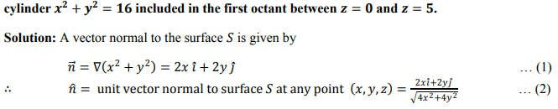
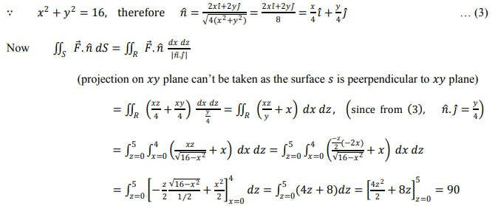
Q6.
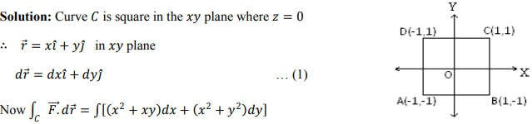

Path of the integration is shown in figure, it consists of lines AB, BC, CD and DA. As curve C is a square, then

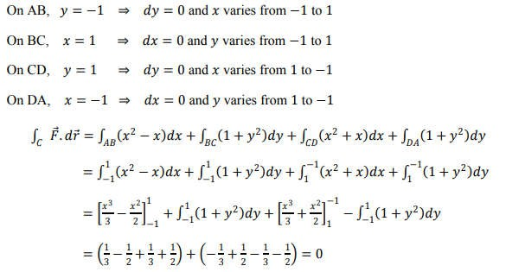
Q7. A vector field F→ is given by F→ = (sin y)ı̂ + x(1 + cos y)ĵ. Evaluate the line
integral fC ¯F→ · dr→ , where C is the circular path given by x² + y² = a².
Solution. Given vector fieldF→ = (sin y)ı̂ + x(1 + cos y)ĵ.

∴ Required line integral =fC
¯F→ · dr→

=fC {(sin y)ı̂ + x(1 + cos y)ĵ} · (dxı̂ + dyĵ + dzk^)

= fC
[(sin y)dx + x(1 + cos y)dy] = fC
(Mdx + Ndy), (1)

where M = sin y and N = x(1 + cos y). (2)
Using Green’s theorem, we have
f (Mdx + Ndy) = ∬ (6N − 6M) dxdy

C S 6x 6y

= ∬S
= ∬S
= πa².
[(1 + cos y) − cos y]dxdy, by (2)

dxdy = area of the circle of radius a

Putting this value in (1), we get
Required line integral =fC ¯F→ · dr→ = πa .
2

Q8. A variable plane passes through a fixed point (a, b, c) and cuts the coordinate axes at A, B,
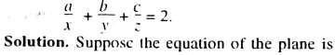
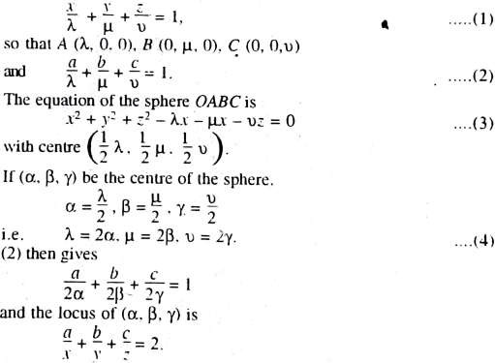





C. Show that the locus of the centre of the sphere OABC is
Q9.

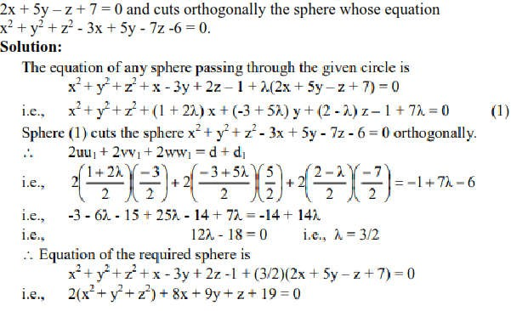

Q10. Find the equation of the right circular cone generating by three straight lines drawn from the origin to cut the circle through three points (1, 2, 2), (2, 1, – 2) and
(2, – 2, 1).
Solution. Here the vertex of the cone is origin (0, 0, 0).
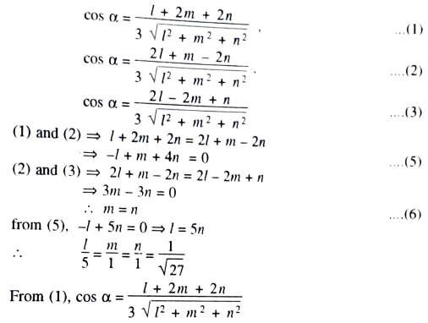
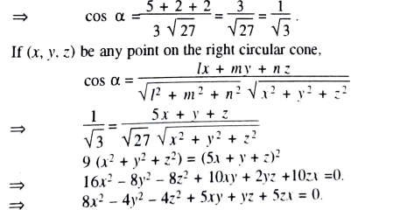
Ifα is the semi-vertical angle of the cone and l, m, n be the d.r.’s of the axis of the cone, we have
Q11. The portion of the curve y = log x for 1 ≤ x ≤ e is rotated about y-axis. Find the area of the surface generated.

Solution. Given that the portion of the curve y = log x for 1 ≤ x ≤ e is rotated about
y-axis. Differentiating it w.r.t. x, we get ^{dy} = ¹ .
dx x
∴ The area of the surface generated is
S = fB 2πx ds = 2πfx2 x ds dx

A x1 dx

= 2πfe x √1 + (dy)2 dx = 2πfe x √1 + 1 dx

1 dx

1 x2

= 2πfe x √x2+1 dx = 2πfe √1 + x²dx
- x 1
= 2π[¹ x√1 + x2 + ¹ log|x + √1 + x2|] e
2 2 1

= π[e√1 + e2 + log(e + √1 + e2) − 1√1 + 1 − log(1 + √1 + 1)]

= π[e√1 + e2 + log(e + √1 + e2) − √2 − log(1 + √2)]. Ans.
Q12. Prove that「(n + 1) = n「n, n > 0.
Proof. By the definition of the gamma function, we have
「n = f∞ x^{n–1}e^{–x}dx, n > 0 (1)
0
Replacing n by n + 1 in (1), we get
「(n + 1) = f∞ x^{n+1–1}e^{–x}dx
0
= f∞ x^{n}e^{–x}dx
0
Integrating by parts, we have
「(n + 1) = [x^{n} (e—x)] ∞ − f∞ kx^{n–1} (e—x) dx
–1 0 0 –1

= – [ lim
(xn) − 0] + k f∞ x^{n–1}e^{–x}dx

x → ∞ ex 0
= – 0 + n「n, by (1).
∴ Proved.
.
「(n + 1) = n「n, n > 0.

π
0
Q13. Evaluate f2 √tan θ dθ.
Solution. We have
π π 1 1
f2 √tan θ dθ = f2 sin2 θ · cos 2 θ dθ (1)

0 0
We know that
π

「(m + 1)「(n + 1)

f2 sin^{m} θ · cos^{n} θ dθ = ² ² (2)
0 2「(m + n + 2)
2
Putting m = ½ and n = – ½ in (2), we get
1 + 1 — 1 + 1

π 1 1
「(2 2 )「( 2 )

f2 sin2 θ · cos– 2 θ dθ =
0
2

1 — 1 + 2
2「(2 2 )
2

「(3)「(1)
= 4 4 =
2「1

¹ 「(
2

¹) 「(1 − ¹)
4 4

= 1 h
, by 「n「(1 – n) = ^{h}

- sin1h
4

sin nh

h 2( 1 )
=
√2
Putting it in (1), we get

π
∴ f2 √tan θ dθ =
0
^{h} . Ans.
√2

Solution. We have y = x² and y = x which implies x² – x = 0 i.e. either x = 0 or x = 1. Further, if x
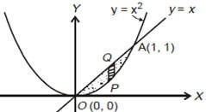
= 0 then y = 0; if x = 1 then y = 1. Means the two curves intersect at points (0, 0), (1, 1). The region R of integration is doted and can be expressed as: x = 0 to 1 and y = x² to x in the figure given below:

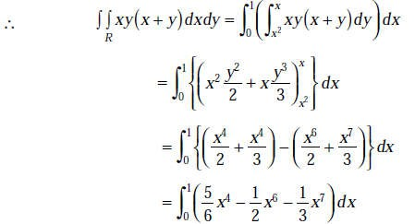
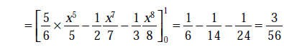 . Ans.
Q15. Find the volume bounded by the cylinder x² + y² = 4 and the planes y + z = 4 and z = 0.
Solution. As shown in the figure, z = 4 – y is to be integrated over the circle x² + y² = 4 in the xy-
4 − y²

plane. To cover the shaded portion, x varies from −
4 − y2
to and y varies from – 2 to 2.

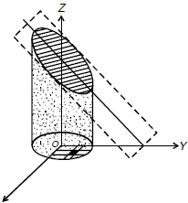
X
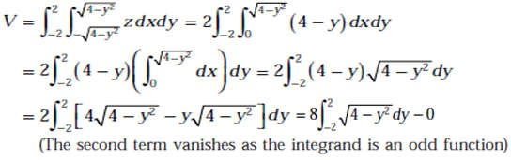
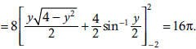
Hence the desired volume is

Ans.

Part C (15 Questions)
Q1. For what values of k, the equations
x + y + z = 1, 2x + y + 4z = k, 4x + y + 10z = k²
have a solution and solve them completely in each case.
Solution. Given equations are
x + y + z = 1, 2x + y + 4z = k, 4x + y + 10z = k². Above system may be written as AX = B,
1 1 1 x 1
where A = [2 1 4 ], X = [y] and B = [ k ].
4 1 10 z k²
Let us take an augmented matrix C = [AǀB].

1 1 1
⇒ C = [2 1 4
4 1 10
1
k ]. k2

Applying R₂ → R₂ ‒ 2R₁ and R₃ → R₃ – 4R₁, we get

1 1 1
C ~ [0 – 1 2
0 – 3 6
1
k– 2 ]. k²– 4

Again performing R₃ → R₃ ‒ 3R₂, we get

1 1 1
C ~ [0 – 1 2
1
k– 2

]. ··································· (1)

0 0 0 k²– 3k + 2
From above echelon form, it is observed that the given system of equations will have a solution, when
ρ(A) = ρ(C) = 2 < 3 (number of unknown variables).
It is possible only when k² ‒ 3k + 2 = 0 and then infinite many solutions exist.
⇒ (k ‒ 1)(k ‒ 2) = 0
⇒ k = 1, 2.
Now from (1), we have
x + y + z = 1, ‒ y + 2z = k ‒ 2.

For k = 1, we have
x + y + z = 1, ‒ y + 2z = ‒ 1.
Let z = a, an arbitrary constant. Then we have
x + y = 1 ‒ a, ‒ y = ‒ 2a ‒ 1.
By back substitution, we have z = a, y = 2a + 1, x = ‒ 3a.
Hence the solution of the given system of equations is
x = ‒ 3a, y = 2a + 1, z = a, where a is an arbitrary constant.
For k = 2, we have
x + y + z = 1, ‒ y + 2z = 0.
Let z = b, an arbitrary constant. Then we have
x + y = 1 ‒ b, ‒ y = ‒ 2b.
By back substitution, we have z = b, y = 2b, x = 1 ‒ 3b.
Hence the solution of the given system of equations is
x = 1 ‒ 3b, y = 2b, z = b, where b is an arbitrary constant.
Q2. Find the eigen values and eigen vectors of the matrix

2  [– 1 | – 1  2 | 1  – 1].
1 | – 1 | 2
2 |  |  | – 1 | 1
Solution. Let A = [– 1 |  |  | 2 | – 1].
1 |  |  | – 1 | 2
The characteristic equation of the matrix A is ǀA ‒ λIǀ = 0.
2– λ | – 1 | 1
⇒ | – 1 | 2– λ | – 1 | = 0
1 | – 1 | 2– λ
⇒ (2 ‒ λ){(2 ‒ λ)² ‒ 1} + 1{‒ 1(2 ‒ λ) + 1} + 1{1 ‒ 1(2 ‒ λ)} = 0
⇒ (2 ‒ λ){ 4 ‒ 4λ + λ² ‒ 1} ‒ 2 + λ + 1 + 1 ‒ 2 + λ = 0
⇒ (2 ‒ λ){λ² ‒ 4λ + 3} + 2λ ‒ 2 = 0

⇒ (2 ‒ λ){(λ ‒ 1) (λ ‒ 3)} + 2(λ ‒ 1) = 0
⇒ (λ ‒ 1){(2 ‒ λ)(λ ‒ 3) + 2} = 0
⇒ (λ ‒ 1){2λ ‒ 6 ‒ λ² + 3λ + 2} = 0
⇒ (λ ‒ 1){λ² ‒ 5λ + 4} = 0
⇒ (λ ‒ 1)(λ ‒ 1)(λ ‒ 4) = 0
⇒ λ = 1, 1, 4.
Now we shall find the eigen vectors of the given matrix A corresponding to the eigen values λ = 1, 1 and 4.
For λ = 1, 1, by (A ‒ λI)X = O, we have
2– 1 – 1 1 x 0
(A ‒ 1I)X = O ⇒ [ – 1 2– 1 – 1 ] [y] = [0]
1 – 1 2– 1 z 0
1 – 1 1 x 0
⇒ [– 1 1 – 1] [y] = [0].
1 – 1 1 z 0
Applying R₂ → R₂ + R₁ and R₃ → R₃ – R₁, we get
1 – 1 1 x 0
⇒ [0 0 0] [y] = [0].
0 0 0 z 0
⇒ x ‒ y + z = 0.
If we choose x = 1, y = 0, then z = ‒ 1 and if we choose x = 0, y = 1, then z = 1.
x 1 0
⇒ X = [y] = [ 0 ] , [1].
z – 1 1
For λ = 4, by (A ‒ λI)X = O, we have
2– 4 – 1 1 x 0
(A ‒ 4I)X = O ⇒ [ – 1 2– 4 – 1 ] [y] = [0]
1 – 1 2– 4 z 0
– 2 – 1 1 x 0
⇒ [– 1 – 2 – 1] [y] = [0].
1 – 1 – 2 z 0

Applying R₁ ↔ R₃, we get
1 – 1 – 2 x 0
[– 1 – 2 – 1] [y] = [0].
– 2 – 1 1 z 0
Now applying R₂ → R₂ + R₁ and R₃ → R₃ + 2R₁, we get
1 – 1 – 2 x 0
[0 – 3 – 3] [y] = [0].
0 – 3 – 3 z 0
Further applying R₃ → R₃ – R₂, we get
1 – 1 – 2 x 0
[0 – 3 – 3] [y] = [0].
0 0 0 z 0
⇒ x ‒ y ‒ 2z = 0, ‒ 3y ‒ 3z = 0.
Let z = 1. It gives y = ‒ 1 and x = ‒ 1 + 2 = 1. Hence we get
x 1
X = [y] = [– 1].
z 1
Thus the eigen values of the given matrix A are 1, 1 and 4 and the corresponding
1 0 1
Eigen vectors are [ 0 ], [1] and [– 1].
– 1 1 1
Q3. Find the eigen values and corresponding eigen vectors for the matrix
– 1 2 – 2
A = [ 1 2 1 ].
– 1 – 1 0
Also reduce it to the diagonal form. Obtain the modal matrix.
– 1 2 – 2
Solution. Given A = [ 1 2 1 ].
– 1 – 1 0
The characteristic equation of the matrix A is ǀA ‒ λIǀ = 0.

– 1– λ 2 2
⇒ | 1 2– λ 1
– 1 – 1 0– λ
| = 0

⇒ (‒ 1 ‒ λ){(2 ‒ λ)(‒ λ) + 1} ‒ 2{‒ λ + 1} ‒ 2{‒ 1 + 1(2 ‒ λ)} = 0
⇒ ‒ (1 + λ){‒ 2λ + λ² + 1} ‒ 2{1 ‒ λ} ‒ 2{1 ‒ λ} = 0
⇒ ‒ (λ + 1){(λ ‒ 1)²} + 2(λ ‒ 1) + 2(λ ‒ 1) = 0
⇒ (λ + 1)(λ ‒ 1)² ‒ 4(λ ‒ 1) = 0
⇒ (λ ‒ 1){(λ +1)(λ ‒ 1) ‒ 4} = 0
⇒ (λ ‒ 1){ λ² ‒ 1 ‒ 4} = 0 ⇒ (λ ‒ 1){ λ² ‒ 5} = 0
⇒ (λ ‒ 1)(λ ‒ √5)(λ + √5) = 0
⇒ λ = 1, √5, ‒ √5.
x₁ x₂ x₃
Now let X₁ = [y1], X₂ = [y2] and X₃ = [y3] be the eigen vectors of the given
z₁ z₂ z₃
matrix A corresponding to the eigen values λ = 1, √5 and ‒ √5 respectively.
For λ = 1, by (A ‒ λI)X = O, we have
– 1– 1 2 – 2 x1 0
(A ‒ 1I)X₁ = O ⇒ [ 1 2– 1 1 ] [y1] = [0]
– 1 – 1 0– 1 z1 0
– 2 2 – 2 x1 0
⇒ [ 1 1 1 ] [y1] = [0].
– 1 – 1 – 1 z1 0
Applying R₁ ↔ R₂, we get
1 1 1 x1 0
⇒ [– 2 2 – 2] [y1] = [0].
– 1 – 1 – 1 z1 0
Again applying R₂ → R₂ + 2R₁ and R₃ → R₃ + R₁, we get
1 1 1 x1 0
⇒ [0 4 0] [y1] = [0].
0 0 0 z1 0
⇒ x₁ + y₁ + z₁ = 0, y₁ = 0.

Let x₁ = 1. It gives z₁ = ‒ 1. Hence we get
x1 1
X₁ = [y1] = [ 0 ].
z1 1
For λ = √5, by (A ‒ λI)X = O, we have
– 1– √5 2 – 2 x2 0

(A ‒ √5I)X₂ = O ⇒ [
1 2– √5 1
] [y2] = [0].

Applying R₁ ↔ R₂, we get
– 1 – 1 0– √5 z2 0

1 2– √5 1 x2 0
⇒ [– 1– √5 2 – 2 ] [y2] = [0].
– 1 – 1 – √5 z2 0
Again applying R₂ → R₂ + (1 + √5)R₁ and R₃ → R₃ + R₁, we get
x2 0
1 | 2– √5 | 1
⇒ [0  0 | √5 – 1 1– √5 | √5 – 1 1– √5

] [y2] = [0].
z2 0
Now applying R → R ‒ (^{1–√5})R , we get
3 3 2
√5 –1
1 2– √5 1 x2 0
⇒ [0 √5 – 1 √5 – 1] [y2] = [0].
0 0 0 z2 0
⇒ x₂ + (2 ‒ √5)y₂ + z₂ = 0, (√5 ‒ 1)y₂ + (√5 ‒ 1)z₂ = 0.
Let z₂ = 1. It gives y₂ = ‒ 1 and x₂ = 1 ‒ √5. Hence we get
x2 1– √5

X₂ = [y2] = [
z₂
– 1 ].
1

For λ = ‒ √5, by (A ‒ λI)X = O, we have
– 1 + √5 2 – 2 x3 0

(A + √5I)X₃ = O ⇒ [
1 2 + √5 1
] [y3] = [0].

Applying R₁ ↔ R₂, we get
– 1 – 1 0 + √5 z3 0

1 2 + √5 1 x3 0
⇒ [– 1 + √5 2 – 2] [y3] = [0].
– 1 – 1 √5 z3 0
Again applying R₂ → R₂ + (1 ‒ √5)R₁ and R₃ → R₃ + R₁, we get
x3 0
1 | 2 + √5 | 1
⇒ [0  0 | – √5 – 1  1 + √5 | – √5 – 1  1 + √5

] [y3] = [0].
z3 0
Now applying R₃ → R₃ + R₂, we get
1 2 + √5 1 x3 0
⇒ [0 – √5 – 1 – √5 – 1] [y3] = [0].

0 0 0
z3 0

⇒ x₃ + (2 + √5)y₃ + z₃ = 0, (‒ √5 ‒ 1)y₃ + (‒ √5 ‒ 1)z₃ = 0.
Let z₃ = 1. It gives y₃ = ‒ 1 and x₃ = 1 + √5. Hence we get

x₃
X₃ = [y3] = [
z₃
1 + √5
– 1 ].
1

Thus the eigen values of the given matrix A are 1, √5 and ‒ √5 and the

1 1– √5
1 + √5

corresponding eigen vectors are [ 0 ], [ – 1
– 1 1
] and [ – 1 ].
1

The given matrix A is now reduced to the diagonal form as
1 0 0
P^{‒1}AP = D = [0 √5 0 ],
0 0 – √5

1 1– √5
1 + √5

where P = [ 0 1
– 1 1
– 1 ] is the modal matrix.
1

Q4. Verify Cayley-Hamilton theorem for the matrix

2 | 1 | 1
A = [– 1 | 2 | – 1]. Hence find A^{‒1}.
1 | – 1 | 2

2 | 1 | 1
Solution. Given A = [– 1 | 2 | – 1].
1 | – 1 | 2
The characteristic equation of the matrix A is ǀA ‒ λIǀ = 0.
2– λ | 1 | 1
⇒ | – 1 | 2– λ | – 1 | = 0
1 | – 1 | 2– λ
⇒ (2 ‒ λ){(2 ‒ λ)² ‒ 1} ‒ 1{‒ 1(2 ‒ λ) + 1} + 1{1 ‒ 1(2 ‒ λ)} = 0
⇒ (2 ‒ λ){ 4 ‒ 4λ + λ² ‒ 1} + 2 ‒ λ ‒ 1 + 1 ‒ 2 + λ = 0
⇒ (2 ‒ λ){λ² ‒ 4λ + 3} = 0
⇒ 2λ² ‒ 8λ + 6 ‒ λ³ + 4λ² ‒ 3λ = 0
⇒ ‒ λ³ + 6λ² ‒ 11λ + 6 = 0
⇒ λ³ ‒ 6λ² + 11λ ‒ 6 = 0 (1)
According to Cayley-Hamilton theorem, matrix A satisfies above characteristic equation (1) so that
A³ ‒ 6A² + 11A ‒ 6I = O (2)
Here we need to verify above equation (2). So we have to find A² and A³.

2 1 1
2 1 1
4 3 3

∴ A² = AA = [– 1 | 2 | – 1] [– 1 | 2 | – 1] = [– 5 | 4 | – 5]
1 | – 1 | 2 1 | – 1 | 2 5 | – 3 | 6
4 | 3 | 3 2 | 1 | 1 8 | 7 | 7
& A³ = A²A = [– 5 | 4 | – 5] [– 1 | 2 | – 1] = [– 19 | 8 | – 19].
5 | – 3 | 6 1 | – 1 | 2 19 | – 7 | 20
Putting the values of A³, A², A and I, we have
L.H.S. of (2) = A³ ‒ 6A² + 11A ‒ 6I

8 | 7 | 7 | 4 | 3 | 3 | 2 | 1 | 1 | 1 | 0 | 0
= [– 19 | 8 | – 19] ‒ 6[– 5 |  | 4 | – 5] + 11[– 1 |  | 2 | – 1] ‒ 6[0 |  | 1 | 0]
19 | – 7 | 20 5 |  | – 3 | 6 1 |  | – 1 | 2 0 |  | 0 | 1

8 − 24 + 22 − 6 |  |  | 7 − 18 + 11 − 0 | 7 − 18 + 11 − 0
= [– 19 + 30 − 11 − 0 |  |  | 8 − 24 + 22 − 6 | – 19 + 30 − 11 − 0]
19 − 30 + 11 − 0 |  |  | – 7 + 18 − 11 − 0 | 20 − 36 + 22 − 6
0 | 0 | 0
= [0 | 0 | 0]
0 | 0 | 0
= O
= R.H.S. of (2).
So the given matrix A satisfies its characteristic equation (1).
Hence the Cayley-Hamilton theorem is verified for the given matrix A. Now multiplying equation (2) by A^{‒1}, we have
A² ‒ 6A + 11I ‒ 6A^{‒1} = O.
⇒ 6A^{‒1} = A² ‒ 6A + 11I

4 3 3
2 1 1
1 0 0

= [– 5 4 – 5] ‒ 6[– 1 2 – 1] + 11 [0 1 0]

5 – 3 6
1 – 1 2
0 0 1

4 − 12 + 11 |  |  | 3 − 6 + 0 | 3 − 6 + 0
= [ – 5 + 6 + 0 |  |  | 4 − 12 + 11 | – 5 + 6 + 0 ]
5 − 6 + 0 |  |  | – 3 + 6 + 0 | 6 − 12 + 11
3 | – 3 | – 3
= [ 1 | 3 | 1 ].
– 1 | 3 | 5
3 – 3 – 3
Hence A^{‒1} = 1 [ 1 3 1 ].

V =
Q5. If
6

xiˆ + yˆj + zkˆ
x² + y² + z²
– 1 3 5

, then find the value of divV and curlV .

Solution. We have,

divV = ∇.V = ⎛ iˆ ∂

+ ˆj ∂
+ kˆ ∂ ⎞.⎧⎪
xiˆ + yˆj + zkˆ ⎫⎪

⎜ ∂x ∂y
∂z ⎟ ⎨ ⎬

⎝ ⎠ ⎪⎩ ⎪⎭
x² + y² + z²

ˆ ∂ ⎛
xiˆ + yˆj + zkˆ ⎞
ˆ ∂ ⎛
xiˆ + yˆj + zkˆ ⎞
ˆ ∂ ⎛
xiˆ + yˆj + zkˆ ⎞

= i ⎜ ⎟ + j
⎜ ⎟ + k
⎜ ⎟

∂x ⎜ x² + y² + z² ⎟ ∂y ⎜ x² + y² + z² ⎟ ∂z ⎜ x² + y² + z² ⎟
⎝ ⎠ ⎝ ⎠ ⎝ ⎠

∂ ⎛ x ⎞ ∂ ⎛
y ⎞ ∂ ⎛ z ⎞

= ⎜ ⎟ +
⎜ ⎟ + ⎜ ⎟

∂x ⎜
x² + y² + z² ⎟
∂y ⎜
x² + y² + z² ⎟
∂z ⎜
x² + y² + z² ⎟

⎝ ⎠ ⎝ ⎠ ⎝ ⎠

⎡(x² + y² +
⎢
⎣
1
z² ) 2 .1−
1
- .(x
2
2 + y² + z² )⁻ 12 .2x⎤
⎥⎦

= (x² + y² + z² )²

⎡(x² + y² +
⎢
⎣
1
z² ) 2 .1−
1
- .(x
2
2 + y² + z² )⁻ 12 .2 y⎤
⎥⎦

+ (x² + y² + z² )²

⎡(x² + y² +
⎢
⎣
1
z² ) 2 .1−
1
- .(x
2
2 + y² + z² )⁻ 12 .2z ⎤
⎥⎦

+ (x² + y² + z² )²
2(x² + y² + z² ) 12 2
=
=
2 2 2
(x² + y² + z² ) 2
1
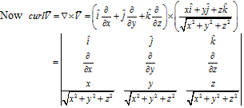
(x + y + z ) .

ˆ⎧⎪ ∂ ⎛ z ⎞ ∂ ⎛

y ⎞⎫⎪

=i ⎨ ⎜ ⎟ −
⎜ ⎟⎬

⎪∂y ⎜
x² + y² + z² ⎟
∂z ⎜
x² + y² + z² ⎟⎪

⎩ ⎝ ⎠ ⎝ ⎠⎭

ˆ ⎧⎪ ∂ ⎛ z ⎞ ∂ ⎛
x ⎞⎫⎪

− j ⎨ ⎜ ⎟ −
⎜ ⎟⎬

⎪∂x ⎜
x² + y² + z² ⎟
∂z ⎜
x² + y² + z² ⎟⎪

⎩ ⎝ ⎠ ⎝ ⎠⎭

ˆ ⎧⎪ ∂ ⎛ y ⎞ ∂ ⎛
x ⎞⎫⎪

+k ⎨ ⎜ ⎟ −
⎜ ⎟⎬

⎪∂x ⎜
x² + y² + z² ⎟
∂y ⎜
x² + y² + z² ⎟⎪

⎩ ⎝ ⎠ ⎝ ⎠⎭

ˆ⎛ − yz yz ⎞
=i ⎜ 3 + ⎟
⎜
⎝
(x + y + z )
2 2 2
2
(x² + y² + z² ) 2
3
⎟
⎠
ˆ⎛ −zx zx ⎞
− j ⎜ 3 + ⎟
⎜
⎝
(x + y + z )
2 2 2
2
(x² + y² + z² ) 2
3
⎟
⎠
ˆ⎛ −xy xy ⎞
+k ⎜ 3 + ⎟
⎜ (x² + y² + z² ) 2 ⎟
(x² + y² + z² ) 2
3
⎝ ⎠
= 0 .
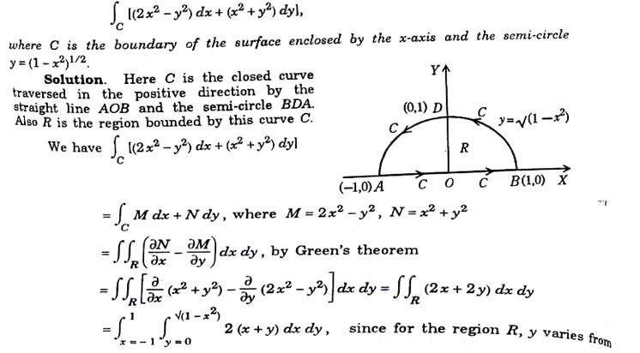
Q6. Apply the Green’s theorem in the plane to evaluate
Q7. Verify the Gauss’s divergence theorem for vector field F→ = (x−y, x+z, z−y⟩ and surface S that consists of cone x² + y² = z², 0 ≤ z ≤1, and the circular top of the cone.
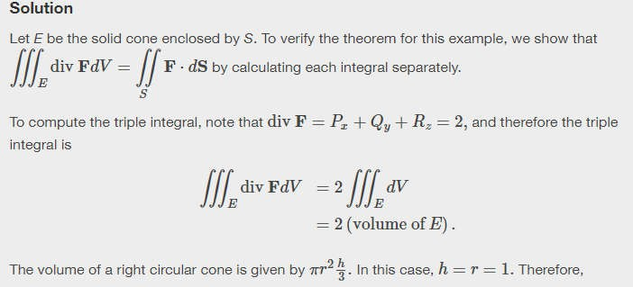






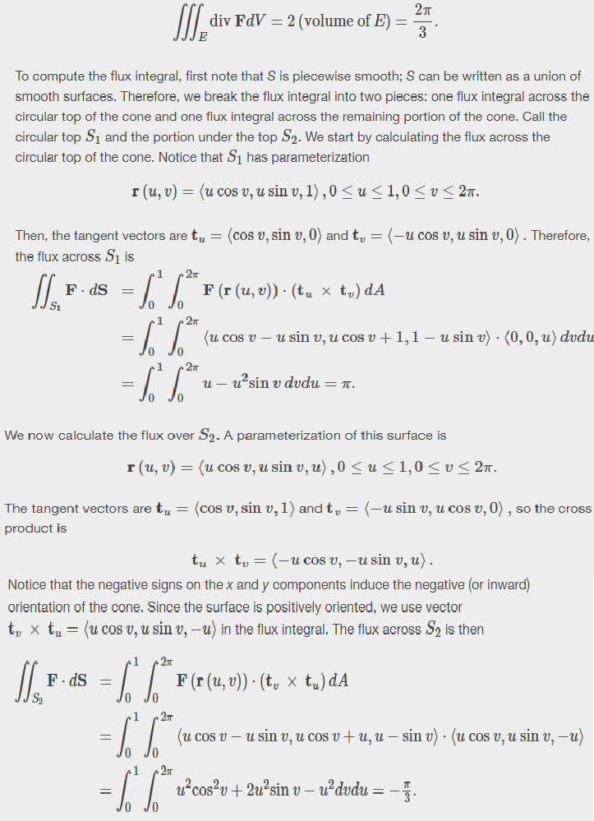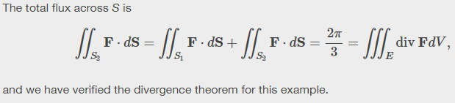

Q8. Verify stoke’s theorem for
F = (x + y)iˆ + (2x − z) ˆj + ( y + z)kˆ
for the surface of a






triangular lamina with vertices (2, 0, 0), (0, 3, 0) and (0, 0, 6).
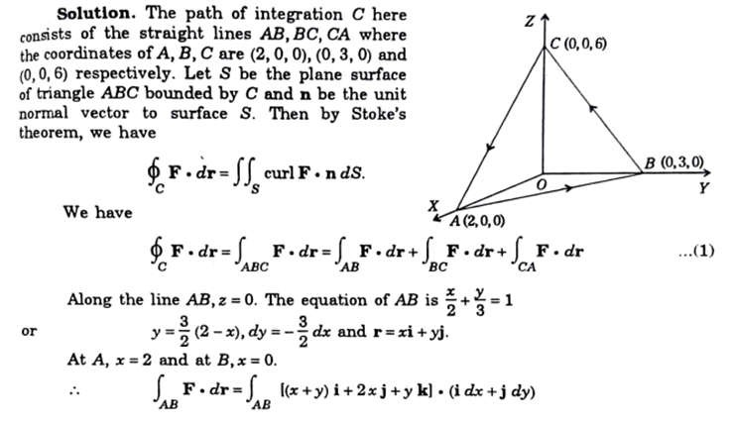
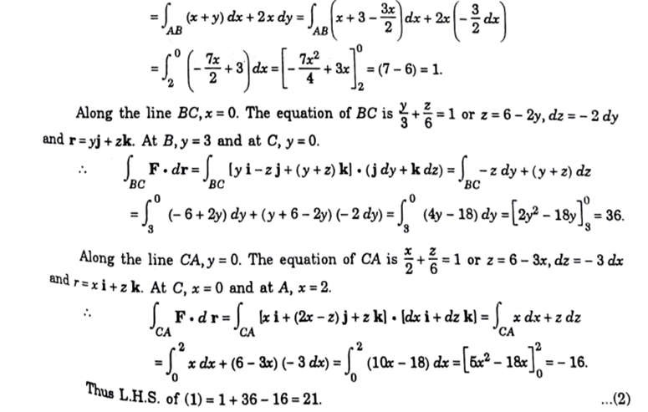

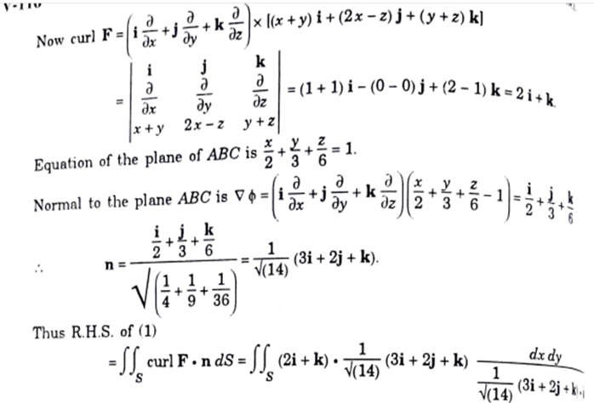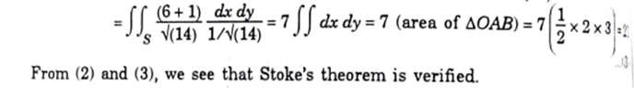
Q9. A sphere of constant radius k passes through the origin O and cuts the axes in A, B.
C. Find the locus of the foot of perpendicular from O to the plane ABC.
Solution. Let the equation of the sphere is
x² + y² + z² + 2ux + 2vy + 2wz + d = 0. (1)
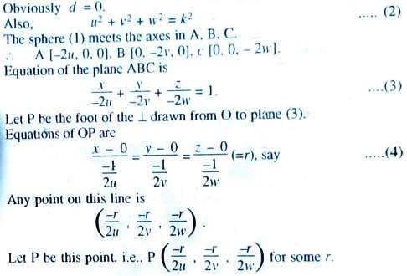

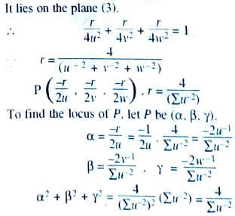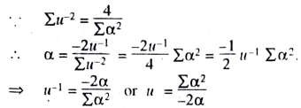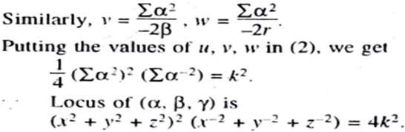
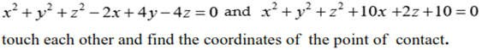
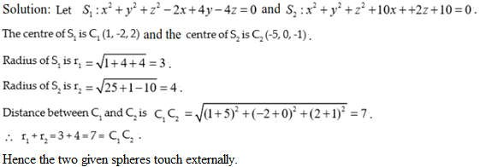
Q10. Prove that the two spheres

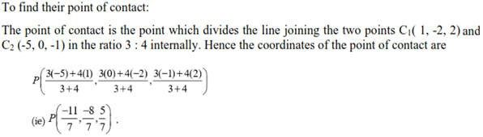
Q11. Obtain the equation of the right circular cylinder described on the circle through the three points (1, 0, 0), (0, 1, 0) and (0, 0, 1) as guiding circle.
Solution. Taking fourth point as (0, 0, 0), the equation of the sphere passing through the four points (0, 0, 0), (1, 0, 0), (0, 1, 0) and (0, 0, 1) is to be determined.
If equation of the sphere is x² + y² + z² + 2ux + 2vy + 2wz + d = 0, then passing through the points (0, 0, 0), (1, 0, 0), (0, 1, 0) and (0, 0, 1), the values d = 0, u = – ½, v = – ½ and w = – ½ are obtained. Hence the equation of the sphere becomes
x² + y² + z² – x – y – z = 0. ….. (1)
Equation of the plane passing through the given three points (1, 0, 0), (0, 1, 0) and
(0, 0, 1) is x + y + z = 0. ….. (2)
Equations (1) and (2) together represent a circle. Now we shall find the centre and radius of this circle.
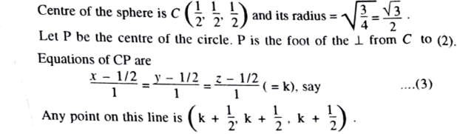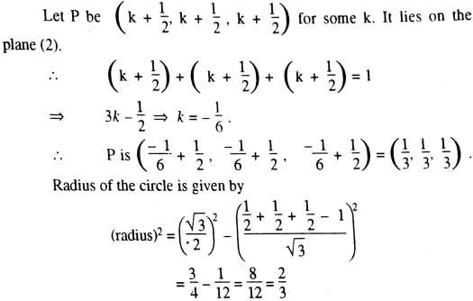

Q12. Calculate the volume of the solid of revolution generated by revolving the hypocycloid (^{x})2/3 + (^{y})2/3 = 1
a b
  - about x- axis, (b) about y- axis.
Solution. Given curve (hypocycloid) is

x 2/3
+
y 2/3
= 1 ········· (1)




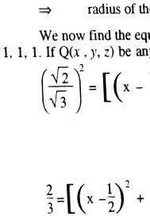
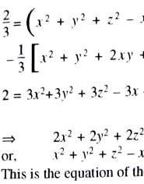





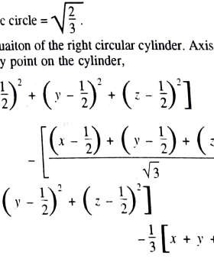
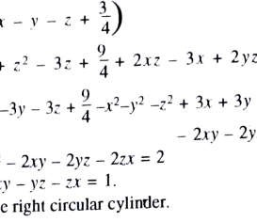
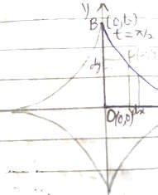

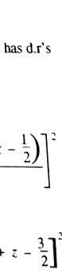
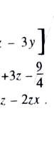
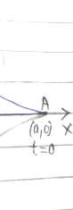
(a) (b)
Let us take parametric equations x = a cos³ t, y = b sin³ t ··· (2) Here t is paremeter.

Curve is symmetrical about both the axes.
    - Volume of the solid of revolution by revolving curve (1) about x-axis
= 2fA πy² dx = 2fa πy² dx
0 0
= 2ft2 πy² dx dt

t1
x | 0 | a
t | π/2 | 0

= 2πf0
h/2
= 2πf0
h/2
dt
[b sin³ t]² ^{d} (a cos³ t)dt, by (2), limit
.¨
dt
b² sin⁶ t · a3 cos² t (– sin t)dt

= 2π b²a3 fh/2 sin⁷ t · cos² t dt , using a property of definite integral
0
「(7+ 1)「( 2+ 1)
= 6πab² ² ² , by gamma function formula
2「(7+ 2 + 2)
2

「4「( 3)
= 6πab² ²
2「(11)

2
= ^{32πab}2 . Ans.

105
3!×1√h
= 6πab² ²
2 2 2 2 2

2×9·7·5·3·1√h
, by 「(n + 1) = n「n

    - By symmetry, the volume of the solid of revolution by revolving curve (1) about y-axis
= ^{32πa}2b . Ans.
105

Q13. Prove that β(m, n) = f∞
0
xm—1 (1+x)m+n
dx, m > 0, n > 0.

Proof. By the definition of the beta function, we have
β(m, n) = f1 x^{m–1}(1 − x)n–1dx, m > 0, n > 0 (1)
0
Let x = ¹ . So dx = − ¹ dy and 1 + y = ¹ ⇒ y = ¹ – 1 for limit of y.

1+y (1+y)2 x x

Also 1 – x = 1 – ¹
1+y
= ^{y} .
1+y

Putting these values in (1), we get
x | 0 | 1
y = ¹ – 1  x | ∞ | 0

β(m, n) = f0 1
yn—1 {−
¹ } dy , .¨ limit

∞ (1+y)m—1 (1+y)n—1 (1+y)2

= f∞
0
yn—1 (1+y)m+n
dy, by a property of definite integral

Again using a property of definite integral, we have

β(m, n) = f∞
0
xn—1 (1+x)m+n
dx (2)

Interchanging m and n in (2), we get

β(n, m) = f∞
0
xm—1 (1+x)n+m
dx (3)

By symmetry, we have β(m, n) = β(n, m)

= f∞
0
xm—1 (1+x)n+m
dx by (3)

∴ Proved.
β(m, n) = f∞
0
xm—1
(1+x)m+n
dx, m > 0, n > 0.

Q14. Evaluate
1 2 x− x²
0 x x
2x − x²
∫ ∫
² + y² dxdy

by changing to polar coordinates.

Solution. Here
x ≤ y ≤
& 0 ≤ x ≤ 1.

The region of integration is bounded by the line y = x and the circle
y² = 2x − x² , i.e. x² − 2x + y ² = 0, i.e. (x −1)² + y² = 1.

Changing to polar coordinates, we put Then we have
x = r cosθ
and
y = r sin θ .

x = 0 ⇒ r cosθ = 0 ⇒ r = 0,θ = π ;
2
y² = 2x − x² ⇒ x² + y² = 2x ⇒ r² = 2r cosθ ⇒ r = 2 cosθ ;

y = x
⇒ r cosθ = r sinθ
⇒ θ = π .
4
π

∴ I = ∫ ∫
1
0
x
2 x−x²
x² + y² dxdy = ∫
2 ∫2 cosθ r 2 drdθ

π 2 ⎡ r3 ⎤2cosθ
π
4 0
= ∫ ⎢ ⎥ dθ

= 8 ∫π

² cos³ θdθ

π 4 ⎣ 3 ⎦0
3 π 4

Let sinθ = t ⇒ cosθdθ = dt
and limit t =
1 to t = 1.

∴ I =
₈ ∫1

(1 − t ² )dt =
2
8 ⎛ t −
t ³ ⎞1
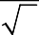
⎟
2

3 1
2
3 ⎝ 3 ⎠1

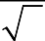
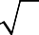
= 8 ⎧
2
⎜
⎩ ⎭
1 1 1 ⎫
2 ( ) . Ans.

3 ⎨1− 3 − + 2 2.3⎬ = 9
8 − 5

